Row Level Security:

Go to IDT Client & Create ROWSecurity.unx

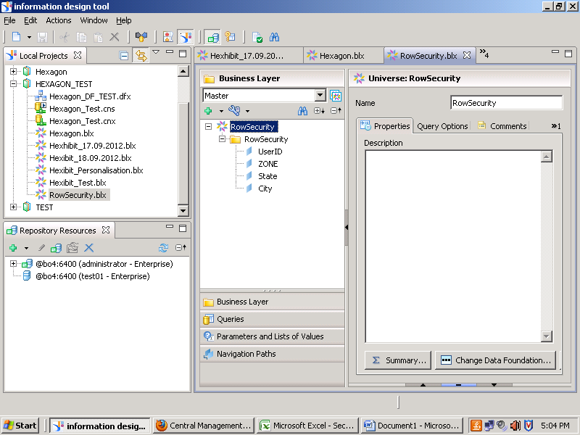

The Universe Columns will be Responsible to Filter Rows.

Go to Explorer-🡪Manage Spaces: Select Universe

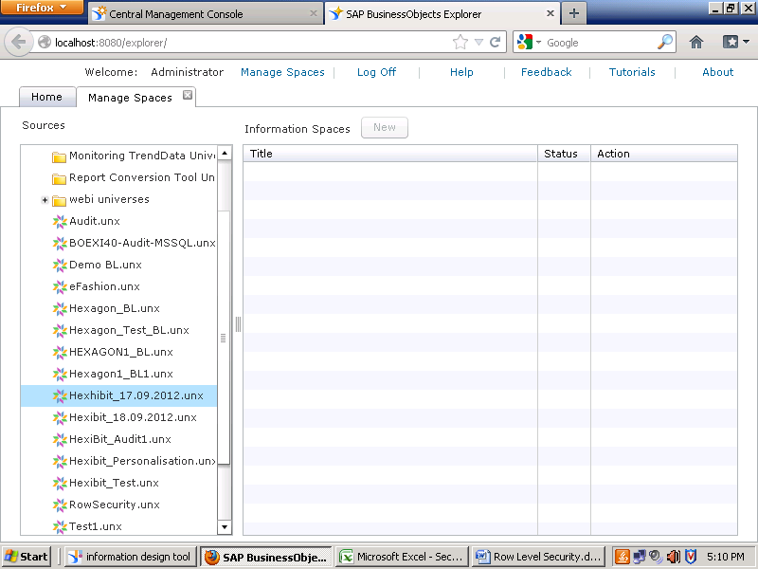

Select Information Space:

Go to Personalisation

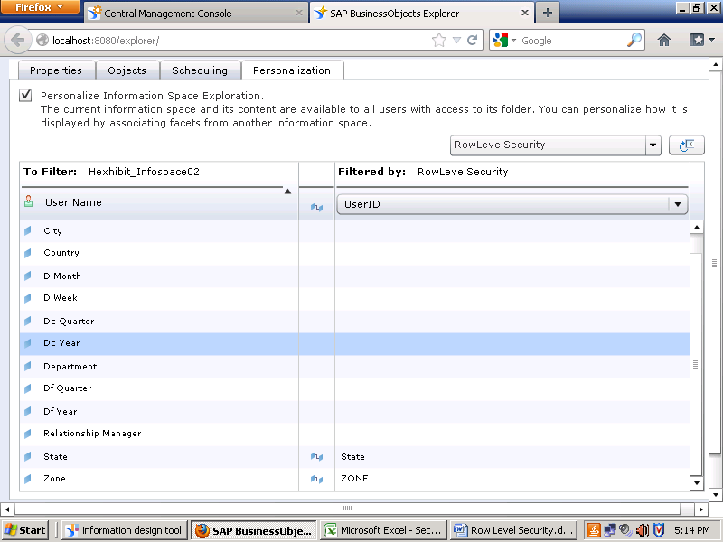

Do the Indexing and check the row level security.